

# “DETECTION OF BONE FRACTURE USING AT LAB”

## A MINI PROJECTREPORT

***Submitted by:***

**KIRAN JANGID (1NH18EC726)**

**MERVIN FRANCIS (1NH18EC738)**

**NAGARATNA NAIK (1NH19EC404)**

*In partial fulfilment for the award of the degree of*

### BACHELOR OF ENGINEERING

**IN**

**ELECTRONICS AND COMMUNICATION ENGINEERING**

**TABLE OF CONTENTS**

ABSTRACT

**CHAPTER 1**

INTRODUCTION................................................................................................................5

**CHAPTER 2**

LITERATURE SURVEY……………………………………………………………………….…….....7

**CHAPTER 3**

MATLAB……………………………………………..………….10

**CHAPTER 4**

PROJECT DESCRIPTION …………………………………………………..……………16

PROPOSED METHODOLOGY………………………………………………….................21

**CHAPTER 5**

RESULT……………………….……………………………………………………………27

**CHAPTER 6**

CONCLUSIONANDFUTURESCOPE….............................................……………………30

REFERENCE……..…………………………………………………………………….….33

APPENDIX…………………………………………………………………………….…..34

**LIST OF FIGURES**

|  |  |  |  |
| --- | --- | --- | --- |
| **SL**  **No** | **FIGURE**  **No** | **FIGURE DESCRIPTION** | **Page**  **No** |
| 1 | 1 | Initialization of laser and LDR | 4 |
| 2 | 2 | Survey of accidents due to rash driving | 5 |
| 3 | 3 | Circuit diagram | 7 |
| 4 | 4 | 555 timer | 9 |
| 5 | 5 | Internal design of 555 timer | 9 |
| 6 | 6 | Circuit diagram Monostable state | 12 |
| 7 | 7 | Circuit diagram of bistable state | 13 |
| 8 | 8 | Resistor | 15 |
| 9 | 9 | Variable resistor | 15 |
| 10 | 10 | Capacitor | 16 |
| 11 | 11 | Diodes | 17 |
| 12 | 12 | Pin configuration IC CD4026 | 21 |
| 13 | 13 | Internal design of IC cd4011 | 23 |
| 14 | 14 | Led bulb | 25 |
| 15 | 15 | Seven segment display | 26 |
| 16 | 16 | LDR | 26 |
| 17 | 17 | Laser | 27 |
| 18 | 18 | Switch | 28 |
| 19 | 19 | Top view of a bread broad | 29 |
| 20 | 20 | Project on completion | 34 |

**ABSTRACT**

**The bone fracture is a very common problem in human beings which occurs due to high**

**pressure applied on bones and also sometimes due to osteoporosis and bone cancer. Hence the**

**accurate the diagnosis of the bone fracture is very important aspect . Generally we use Xrays**

**and CT scan images to detect the bone fracture. The aim of the project is to develop an image**

**processing technique for a quick and accurate classification of bone fracture based on the**

**information gained from the Xray nd CT scan images. The images obtained are been processed**

**through various techniques like pre-processing, segmentation, edge detection and feature**

**extraction method. Then the processed images are further classified into fractured and non-**

**fractured bone and compare the accuracy of different methods. This project is fully been**

**employed by MATLAB as the programming tool for loading and image processing and user**

**interface development. Results obtained will demonstrate the performance of the bone**

**fracture detection system with some limitations and good accuracy.**

**Keywords**: List of Keywords

* X-ray
* CT scan
* Magnetic resonance image (MRI)
* ultra sound
* portable device
* FFT
* MATLAB

**Chapter 1**

INTRODUCTION

Bones are the solid organs in our human body that protects many important organs such as

brain, lungs, and other internal organs. The human body on the whole has 206 bones with

various shapes, size and structures. The longest bones in our body are the femur bones and the

smallest bones being the auditory ossicles. The Bone fracture is a very common problem in

human beings. Bone fractures may occur due to various reasons some due to accident or when

high pressure is applied on the bones. The different types of bone fracture that occurs are

oblique, compound, comminute, spiral, greenstick and transverse. There exist different types

of medical imaging tools for detecting the bone fractures like X-rays, CT, magnetic resonance

image, ultrasound etc. Out of which X-rays and CT are most frequently used because it is the

fastest and easiest way for the doctors to study the injury. The characteristic therapeutic

imaging mechanical assemblies are in adequate. Smart and exact assurance can be critical to be

accomplished for the supported treatment. Using this technique has caused some frightful

bumbles upon humans. By automating the discovering methodology has been greatly helpful.

Similarly, with the help of other PC discovering frameworks are Diminishing human mix-ups and

Decreasing the time\effort for getting the result. Thus, searching for a type of case (e.g., for

research structures ) is usually done physically which takes a lot of time\effort and is super

costly too. Giving a mechanically assembly that can encounter a huge database of pictures will

speed up the process and give high accuracy too. Thereby, it reduces the enormous number of

blunders in such records. X-ray pictures are most generally used to deal with recognize the

problems in our human body. This is a shadow-like picture. But when compared to quality the

CT and MRI pictures give better quality pictures of the body organs. They are far more faster

and affordable. There are various sorts of bone splits Direct, corner to corner, compound,

drove, winding and Green stick.

**Chapter 2**

LITERATURE SURVEY

1.Shubhangi D.C, RaghavendraS.Chinchansoor, P.S Hiremath, &quot;Edge Detection of Femur

Bones in X-ray images - A Comparative study of Edge Detectors&quot;, International Journal of

Computer Applications Volume 42o.2, March 2012.

2. Malashree, G.Narayanaswamy, &quot;Automatic detection of radius of bone fracture&quot;,

International Research Journal of Engineering and Technology, Volume: 04 Issue: 06,

June -2017.

3. S.K.Mahndran, S.SanthoshBaBoo, &quot;An Ensemble Systems for Automatic Fracture

Detection&quot;, IACIT International Journal of Engineering and Technology, Vol.4, No. 1,

February 2012.

4. Mahmoud Al-Ayyoub, Duha Al-Zghool, &quot;Determining the Type of Long Bone Fractures in

X-Ray Images&quot;,EISSN: 2224-3402, Issue 8, Volume 10, August 2013.

5. Robert P. Velthuizen, Lawrence 0. Hallt, Laurence P. Clarke, &quot;MRI Feature Extraction Using

Genetic Algorithms&quot;, 18th Annual International Conference of the IEEE Engineering in Medicine

and Biology Society, Amsterdam, pp 1138-1139, 1996.

6. D. Marr and E. Hildreth, &quot;Theory of edge detection&quot;, Proc. Royal Soc. of London, vol.

207,pp. 187-217, 1980.

7. San Myint, AungSoeKhaing, HlaMyoTun, &quot;Detecting Leg Bone Fracture In X-Ray Images&quot;,

International journal of scientific &amp; technology research, Volume 5, Issue 06, June 2016.

8. Samuel FebriantoKurniawan .KetutGedeDarma Putra ,A.A Kompiang Oka Sudana, “BONE FRACTURE DETECTION USING OPENCV”, Department of Information Technology, Udayana University, Indonesia,June 2014, Vol. 64 No.1.

9. PinakiPratimAcharjya, Ritaban Das &DibyenduGhoshal “Study and Comparison of Different Edge Detectors for Image Segmentation” ,Bengal Institute of Technology and Management Santiniketan, West Bengal, India.

10. “Implication of image processing algorithm in remote sensing and gis applications”, Faculty of Forestry, University Putra Malaysia.  
11. “AdAgen: Adaptive Interface Agent for X-ray Facture Detection” Arab academy for science and technology maritime transport, Egypt , December 2004, Vol.2 No.3.

12. “Canny Edge Detection”, 09gr820, March 23, 2009.

13. P. Bhuvaneswari, Dr. A. Brintha Therese “Edge Detection Techniques in Digital and Optical Image Processing” IP. Bhuvaneswari et al Int. Journal of Engineering Research and Applications, may 2014, Vol. 4, Issue 5( Version 3).

14. “Implementing Edge Detection for Medical Diagnosis of a Bone in Matlab” 5th International Conference on Computational Intelligence and Communication Networks, 2013.

15. K.M.M. Rao “Overview of image processing” NRSA,Hyderabad.

**Chapter 3**

**MATLAB :**

The function [y1,...,yN] = myfun(x1,...,xM) declares a function named myfun that accepts inputs x1,...,xM and returns outputs y1,...,yN. This declaration statement must be the first executable line of the function. Valid function names begin with an alphabetic character, and can contain letters, numbers, or underscores.

You can save your function:

* In a function file which contains only function definitions. The name of the file must match the name of the first function in the file.
* In a script file which contains commands and function definitions. Functions must be at the end of the file. Script files cannot have the same name as a function in the file. Functions are supported in scripts in R2016b or later.

Files can include multiple local functions or nested functions. For readability, use the [end](https://www.mathworks.com/help/matlab/ref/end.html) keyword to indicate the end of each function in a file. The end keyword is required when;

* Any function in the file contains a nested function.
* The function is a local function within a function file, and any local function in the file uses the end keyword.
* The function is a local function within a script file.

MATLAB is a high-performance language for technical computing. It integrates computation, visualization, and programming in an easy-to-use environment where problems and solutions are expressed in familiar mathematical notation. Typical uses include:

* Math and computation

* Algorithm development

* Modeling, simulation, and prototyping

* Data analysis, exploration, and visualization

* Scientific and engineering graphics

* Application development, including Graphical User Interface building

MATLAB :  is a programming platform designed specifically for engineers and scientists. The heart of MATLAB is the MATLAB language, a matrix-based language allowing the most natural expression of computational mathematics.

MATLAB is an interactive system whose basic data element is an array that does not require dimensioning. This allows you to solve many technical computing problems, especially those with matrix and vector formulations, in a fraction of the time it would take to write a program in a scalar noninteractive language such as C or Fortran.

The name MATLAB stands for matrix laboratory. MATLAB was originally written to provide easy access to matrix software developed by the LINPACK and EISPACK projects, which together represent the state-of-the-art in software for matrix computation.

**The MATLAB System:**

The MATLAB system consists of five main parts:

**The MATLAB language.**

This is a high-level matrix/array language with control flow statements, functions, data structures, input/output, and object-oriented programming features. It allows both "programming in the small" to rapidly create quick and dirty throw-away programs, and "programming in the large" to create complete large and complex application programs.

**The MATLAB working environment. :**

This is the set of tools and facilities that you work with as the MATLAB user or programmer. It includes facilities for managing the variables in your workspace and importing and exporting data. It also includes tools for developing, managing, debugging, and profiling M-files, MATLAB's applications.

**Handle Graphics.**

This is the MATLAB graphics system. It includes high-level commands for two-dimensional and three-dimensional data visualization, image processing, animation, and presentation graphics. It also includes low-level commands that allow you to fully customize the appearance of graphics as well as to build complete Graphical User Interfaces on your MATLAB applications.

**The MATLAB mathematical function library.**

This is a vast collection of computational algorithms ranging from elementary functions like sum, sine, cosine, and complex arithmetic, to more sophisticated functions like matrix inverse, matrix eigenvalues, Bessel functions, and fast Fourier transforms.

**The MATLAB Application Program Interface (API).**

This is a library that allows you to write C and Fortran programs that interact with MATLAB. It include facilities for calling routines from MATLAB (dynamic linking), calling MATLAB as a computational engine, and for reading and writing MAT-files.

## Graphics and graphical user interface programming[[edit](https://en.wikipedia.org/w/index.php?title=MATLAB&action=edit&section=9" \o "Edit section: Graphics and graphical user interface programming)]

* 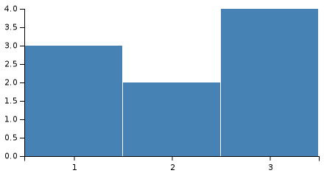

MATLAB has tightly integrated graph-plotting features. For example, the function *plot* can be used to produce a graph from two vectors *x* and *y*. The code:

x = 0:pi/100:2\*pi;

y = sin(x);

plot(x,y)

produces the following figure of the [sine function](https://en.wikipedia.org/wiki/Sine_wave" \o "Sine wave):

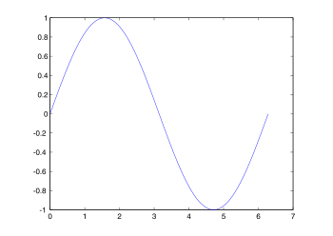

MATLAB supports three-dimensional graphics as well:

MATLAB can call functions and subroutines written in the programming languages [C](https://en.wikipedia.org/wiki/C_(programming_language)" \o "C (programming language)) or [Fortran](https://en.wikipedia.org/wiki/Fortran" \o "Fortran).[[35]](https://en.wikipedia.org/wiki/MATLAB" \l "cite_note-35) A wrapper function is created allowing MATLAB data types to be passed and returned. [MEX files](https://en.wikipedia.org/wiki/MEX_file" \o "MEX file) (MATLAB executables) are the dynamically loadable object files created by compiling such functions.[[36]](https://en.wikipedia.org/wiki/MATLAB" \l "cite_note-36)[[37]](https://en.wikipedia.org/wiki/MATLAB" \l "cite_note-37) Since 2014 increasing two-way interfacing with [Python](https://en.wikipedia.org/wiki/Python_(programming_language)" \o "Python (programming language)) was being added.[[38]](https://en.wikipedia.org/wiki/MATLAB" \l "cite_note-38)[[39]](https://en.wikipedia.org/wiki/MATLAB" \l "cite_note-39)

Libraries written in [Perl](https://en.wikipedia.org/wiki/Perl" \o "Perl), [Java](https://en.wikipedia.org/wiki/Java_(programming_language)" \o "Java (programming language)), [ActiveX](https://en.wikipedia.org/wiki/ActiveX" \o "ActiveX) or [.NET](https://en.wikipedia.org/wiki/.NET_Framework" \o ".NET Framework) can be directly called from MATLAB,[[40]](https://en.wikipedia.org/wiki/MATLAB" \l "cite_note-40)[[41]](https://en.wikipedia.org/wiki/MATLAB" \l "cite_note-41) and many MATLAB libraries (for example [XML](https://en.wikipedia.org/wiki/XML" \o "XML) or [SQL](https://en.wikipedia.org/wiki/SQL" \o "SQL) support) are implemented as wrappers around Java or ActiveX libraries. Calling MATLAB from Java is more complicated, but can be done with a MATLAB toolbox[[42]](https://en.wikipedia.org/wiki/MATLAB" \l "cite_note-42) which is sold separately by [Math Works](https://en.wikipedia.org/wiki/MathWorks" \o "MathWorks), or using an undocumented mechanism called JMI (Java-to-MATLAB Interface),[[43]](https://en.wikipedia.org/wiki/MATLAB" \l "cite_note-43)[[44]](https://en.wikipedia.org/wiki/MATLAB" \l "cite_note-44) (which should not be confused with the unrelated [Java Metadata Interface](https://en.wikipedia.org/wiki/Java_Metadata_Interface" \o "Java Metadata Interface) that is also called JMI). Official MATLAB API for Java was added in 2016.[45

As alternatives to the [MuPAD](https://en.wikipedia.org/wiki/MuPAD" \o "MuPAD) based Symbolic Math Toolbox available from MathWorks, MATLAB can be connected to [Maple](https://en.wikipedia.org/wiki/Maple_(software)" \o "Maple (software)) or Mathematics.[[46]](https://en.wikipedia.org/wiki/MATLAB" \l "cite_note-46)

Libraries also exist to import and export [MathML](https://en.wikipedia.org/wiki/MathML" \o "MathML).

**Functions :**

A function is a group of statements that together perform a task. In MATLAB, functions are defined in separate files. The name of the file and of the function should be the same.

Functions operate on variables within their own workspace, which is also called the **local workspace**, separate from the workspace you access at the MATLAB command prompt which is called the **base workspace**.

Functions can accept more than one input arguments and may return more than one output arguments.

## Anonymous Functions :

An anonymous function is like an inline function in traditional programming languages, defined within a single MATLAB statement. It consists of a single MATLAB expression and any number of input and output arguments.

You can define an anonymous function right at the MATLAB command line or within a function or script.

This way you can create simple functions without having to create a file for them.

## Primary and Sub-Functions :

Any function other than an anonymous function must be defined within a file. Each function file contains a required primary function that appears first and any number of optional sub-functions that comes after the primary function and used by it.

Primary functions can be called from outside of the file that defines them, either from command line or from other functions, but sub-functions cannot be called from command line or other functions, outside the function file.

Sub-functions are visible only to the primary function and other sub-functions within the function file that defines them.

## Nested Functions :

You can define functions within the body of another function. These are called nested functions. A nested function contains any or all of the components of any other function.

Nested functions are defined within the scope of another function and they share access to the containing function's workspace.

## Private Functions :

A private function is a primary function that is visible only to a limited group of other functions. If you do not want to expose the implementation of a function(s), you can create them as private functions.

Private functions reside in **subfolders** with the special name **private**.

They are visible only to functions in the parent folder.

## Global Variables :

Global variables can be shared by more than one function. For this, you need to declare the variable as global in all the functions.

If you want to access that variable from the base workspace, then declare the variable at the command line.

The global declaration must occur before the variable is actually used in a function. It is a good practice to use capital letters for the names of global variables to distinguish them from other variables.

**Chapter 4**

**PROJECT DESCRIPTION**

Major advance to examine picture and concentrate information is picture division. It is an activity of dividing a picture into an accumulation of associated set of pixels. The principle behind this process is to get more data of the picture and explain the article scenario. There are three fundamental methodology of picture division that are in approach, limit approach and edge detection approach. In this process, edge division is utilised which is increasingly reasonable for bone picture. Recognition is a standout amongst the most generally utilised activities in applications that require deciding items limits in a picture. It depends on breaking down the adjustments in the force in picture.

Smart and exact assurance can be risky to know if any supported treatment. Contingent upon human authorities alone for such fundamental issues have caused frightful diseases. Automating the discovering methodology has reliably been a connecting with one. Likewise with other PC helped discovering frameworks, the motivation for discovering frameworks are:

* Diminishing human mix-ups
* Decreasing the effort related with getting ready and knowing specialists

At the end, structure can be inside the result of x-ray image to enable costumers to make an energetic and significantly precise investigations while generating the required image. One more motivation of this work is to support researchers and patients regarding their specific cases. Finally, it reduces the enormous number of blunders in such records. This was viewed from individual experience and confirmed by many experienced specialists. The human body has 206 bones. Every bone has a different shape and structure. The longest bone of our body is femur bone and the softest one is sound related ossicle. There are 5 different types of bones available such as:

* Long
* Short
* Sporadic
* sesamoid
* flat

because of such collection of information, we force on two bits of hand bones:

metacarpals and phalanges, and slightly carpal bones. Bones can suffer breaks paying little mind toothier inflexible nature. Bone breaks can occur because of a straightforward disaster or some other circumstances where in a high weigh is associated on the bones. There are various sorts of bone splits- direct, corner to corner, compound, drove, winding, green stick.

In this process we consider the issue of perceiving breaks near to bones without concentrating on the spot of breaks. This paper gives the detail audit of composing, techniques used for fracture detection and its futures scope.

CODE USING MATLAB:

|  |
| --- |
|  |
|  | I=imread('image.jpg'); |
|  | %ad=imadjust(grayimage,[0.1,0.9],[0.0,1.0]); |
|  | ad=imadjust(grayimage); |
|  | %filtered2=fspecial('average',[3 3]); |
|  | %filtered=imfilter(grayimage,filtered2); |
|  | filtered=imnoise(ad,'salt & pepper',0); |
|  | %sharpen= imsharpen(I); |
|  | %contrast=imcontrast(filtered); |
|  |  |
|  | %pixel\_avg=mean(filtered(:)); |
|  | %perprocessed=pixel\_avg-grayimage; |
|  |  |
|  | SE=strel('disk',3); |
|  | %filtered=imopen(grayimage,SE); |
|  |  |
|  | erosion=imerode(filtered,SE); |
|  | dilation=imdilate(filtered,SE); |
|  | diff=dilation-erosion; |
|  | %image\_dilate\_diff=dilation-grayimage; |
|  | %image\_erode\_diff=erosion-grayimage; |
|  | gradient\_image=filtered-diff; |
|  | SE2=strel('diamond',3); |
|  | new\_dilation=imdilate(gradient\_image,SE2); |
|  |  |
|  | c=edge(new\_dilation,'sobel'); |
|  | figure(1); |
|  | imshow(c); |
|  |  |
|  | c2=edge(new\_dilation,'prewitt'); |
|  | figure(2); |
|  | imshow(c2); |
|  |  |
|  |  |
|  | c3=edge(new\_dilation,'canny',0.2); |
|  | figure(3); |
|  | imshow(  Image processing is the technique to convert an image into digital format and perform operations on it to get an enhanced image or extract some useful information from it. Changes that take place usually perform automatically and rely on carefully designed algorithms. It is a multiple field which contributes different branches of science including engineering. The extraction of information is need to their content has been the driving factor in development of image processing. Image processing finds use in numerous sectors, including medicines, industry, military etc. Complex detection of shoulders or vehicles follow complex image processing algorithms. Fingerprinting, face recognition, hand recognition are biometric techniques which are used extensively in law enforcement and security.  A digital image maybe defined as a two dimensional function f(x,y), where ‘x’ and ’y’ are spatial coordinates and the amplitude of ‘f’ at any pair of coordinates is called as the intensity of the image at that point. When ‘x’, ’y’ and amplitude values of ‘x’ are all finite discreet quantities, the image is referred to as a digital image. Digitising the coordination value is referred to as ‘sampling’, while digitising the amplitude value is called ‘quantisation’. The result of sampling and quantisation is a matrix of real numbers.    A screenshot of a cell phone  Description automatically generated |
|  |  |

X-RAY bone image : It is a diagnostic image. In this the imaging test is ionizing radiation passing through the bones, it enables an image to be produced on film. An x-ray can produce any image of a bone from different multiple angles.

Pre-processing: Image pre-processing is operations on image on lower level, in which the aim is to improve the image data that suppress undesired distortions some image features for further important processing. The image information content does not increase.

Edge Detection: It is an image processing technique to find the boundaries of object within images. Edge detection is to detect discontinuities in brightness. It used for image segmentation and data extraction in areas like computer vision machine vision and image processing.

Segmentation: It divides image into different/separate parts or sections.

Feature Extraction: A type of dimensionality reduction that efficiently represents different parts of an image as compact feature vector. This helps to resize the image and reduces feature representation for quick complete task of image matching.

Classification: a type of machine learning which means learns to classify new observations from example data.

Firstly, we load the code in MATLAB. For a sample image we download the image and save in the same folder where the code has been saved. Before running the code, we open the same folder in any drive and select the sample image, considering the dimensions and pixels. Once this is done, we load the image and run the program, clear all the error if any. Once this is completed, we obtain an image of the x-ray image in three different types. The accuracy of the image is 85% according to the analyses.

Similarly, we can find any bone fracture in any human body. This is one of the fastest and latest method invented for the medical field. The results come in fraction of seconds unlike x-rays .

Data from the image are digitalized and various mathematical operations are applied to the data generally with digital computer.

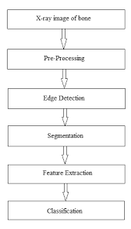

**PROPOSED METHODOLOGY**

In the work of development the MATLAB tool is mainly used because of the substantial number of the image preparing instrument developed under MATLAB. The above sentence begins with expelling the clamour from the x-beam picture which changes over RGB to dark scale. Edge location procedure are used, this means they are examined there are sorts of clamour this sort of commotion is by and large brought about by a disappointment in catch or transmission that is showing up in picture as light and dark dabs as shown.

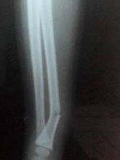

In the proposed work, we are using a filter called salt to pepper noise which protects the edges and sharpness of the picture. This type of immediate filter is, likewise, used lessen the noise from the image while protecting the edges and sharpness of the image. This intermediate filter takes every pixel in the image and checks how different it is from the other pixels. On the chance that is “UNIQUE”, at that point its esteem is sub planted with a centre of its uncompressing pixel. This implies a case of applying disorder evacuation, picture smoothing on x-ray hand image. Edge detection is an important activity in picture handling that decrease quantity of pixels and adjust the structure of image by deciding the limit of protest in the image. In this segment the technique is talking about subtleties. When you run the PC mill it supports the conclusion of frame works that depends on restorative, image handling instrument for commotion expulsion. Image improvement and highlight extraction assume a critical job in achievement of such frameworks. The exchange of equipment utilised for these process of testing stages. The equipment utilised for this work is under MATLAB.

In this sector different methods can be applied to x-ray/CT images are listed and corresponding papers are discussed. This helps the reader in understanding the potential and the amount of efforts/research which has been carried to this field. An attempt has been made in providing short technique details of each slide, for the benefit of researchers in this field. This also represents some common and new tools used for image processing in the study of bone fracture detection. Generally the classification is based on the transformed base which are 2 type of fracture detection technique. We have discussed both techniques. Detection of bone fracture are of three types sobel , prewitt, canny , as shown in the above program, and declared in the code as shown. The result will come in all three type which has been discussed.

The bone is an essential part of body for the approach made through this slide in which the bone is visualized through an algorithm used be the body as a tool. This required approach is focused on locating minor and small fracture in the body through image processing techniques. The input image is an x-ray image which is processed using image processing techniques. In this process the foreground which is a major region of interest in this process is figured out by compressing the background distortion. The mathematical techniques are useful for these type of operation like opening and using edge detection for objects which are highlighted. The image is classified using the SVM into 2 slides of image which are fractured and unfractured. This technique is pre-processing, feature extraction and image classification as shown in above flow chart.

The unwanted distortion in the image like noise are removed from the image and the image is modified to improve the contrast of the given image and obtain a clear image for the further use of feature extraction.

In this way median filter and average filter are used for removing noise from the given image. The value of output pixel for both filters equals to the mean of the pixel magnitude in the neighbourhood around the equivalent input pixels. Median filter gives the magnitude of an output pixel equal to the median value of another output pixel, rather than the mean. The median filter is very less used than the mean to extreme magnitude and know as outliers. Therefore median filter is more effective to eliminate the outliers deprived of decreasing the image sharpness. For the image enhancement logarithmic operator is used. Here the arithmetic operation is used to enhance the contrast of the image. Logarithmic operator is used for scaling down the contrast of brighter region. This is given by an equation:

V= J \* log(1+e)

* J is the factor
* e is the image to which an enhancement must be done

The factor J is decided empirically to get a required level of enhanced image. Next the feature extraction pre-processed image is done. Background will be getting suppressed to figure out foreground. This is done using sobel edge and morphological operation techniques.

MORPHOLOGICAL OPERATIONS:

These are processing operations that route set of images grounded on shapes. It applies a constituting element to an input image for producing an output image of the similar size. Through the comparison of the equivalent pixel in the input image with its neighbours, the magnitude in the output image is established. A morphological operation which is subtle to precise and extract shapes in the output image is created by selecting shape and size of neighbouring pixel. The predominantly used morphological operations are erosion and dilation.

Image processing can be used for various application like:

* Medical imagining
* Forensic studies
* Film industries
* Graphic arts
* Printing industry
* Remote sensing
* Military
* Non-destructive evaluation
* Material science
* Document processing

Image processing techniques are : Image analysis , Image representation, Image data compression, Image reconstruction, Image pre-processing, Image restoration.

EDGE DETECTORS FOR IMAGE ARE:

1. Sobel
2. Laplacian Of Gaussian (LOG)
3. Prewitt
4. Canny
5. Roberts edge detection

SOBEL: Sobel edge detection it is the discrete difference between rows and columns od 3X3. Sobel is based on the image which are small and the part to be scanned. It smooths the pixel and determines the image. This operation is knowns as Sobel . it is the first method comes in the mind of researchers , but this is not only the perfect way of image processing in MATLAB we have other better options available as described above.

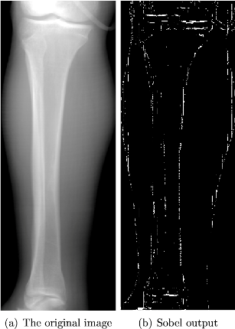

PREWITT: this is one of the oldest the bestest method of edge detection. This detects using mask of approximate digitally Gx, Gy .

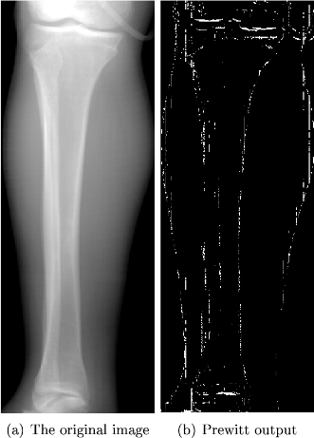

CANNY: it is one was mostly used method since edge detection targets the boundary of the image. This detects the edge and find the local maxima of the image . this is mostly widely edge detection of x-ray image of knee.

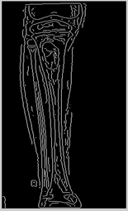

**Advantages and disadvantages**

**Advantages**

* Image processing is very well implemented here
* Automated fracture detection
* Detection of fracture in very less time
* Very compact

**Disadvantages**

* Not fully accurate
* Slight error in algorithm may disrupt the output

**Chapter 5**

**RESULT**

Bone fracture detection system is implementing using MATLAB and its image processing tools. The compare of different type of edge detection has been shown. We have worked on three different type of image processing, edge detection and obtains three images. As result image shows the fracture and enhance the output in the better way. We can see original image n compare with the processed , as a result we can see the defects in processed image easily and fast. Few intermediates such as canny edge detection could recognise peak points of the and fracture took place. Program in MATLAB is shown:

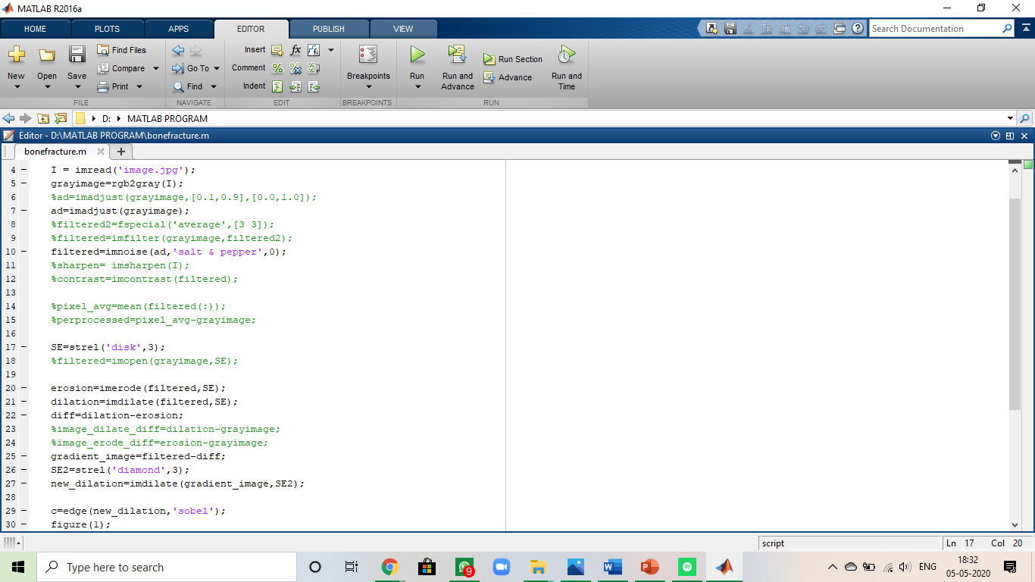

Presenting of image and result is as same the snaps as shown in the above figure. As we can there are two segments peak available in the image , then only fracture can be observed/ detected. Though we have been tested the algorithm using other edge detection techniques and blind deconvolution techniques for removing noise in the pre-processing task, but results are not up to the mark. We have been getting such error , in such issues u must check out your code first and the make sure we upload the image file in the same folder where the program has been saved. Also make sure the image which u r using for the edge detection must be in .jpg file . once we cleared all our error, we got the perfect images of three different type of edge detection what we have declared in the code. According to our code , we have declared three types of image detection:

* Sobel
* Prewitt
* Canny

And our results have come in all three types of edge detection. According to the analysis and study canny is mostly and widely used edge detection all over world under MATLAB.

The result of image in all three types of edge detections are as shown:

Sobel:

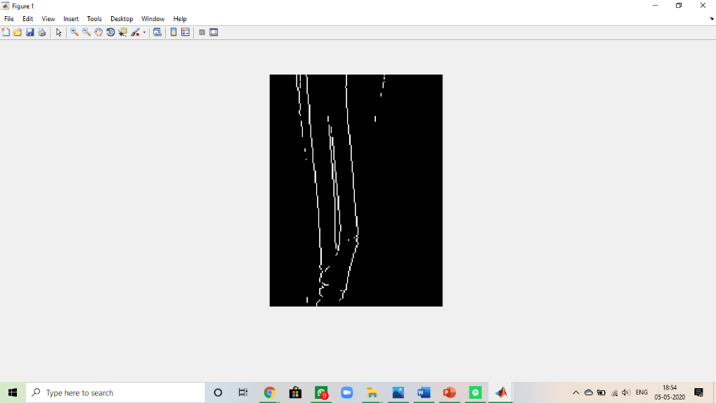

Prewitt:

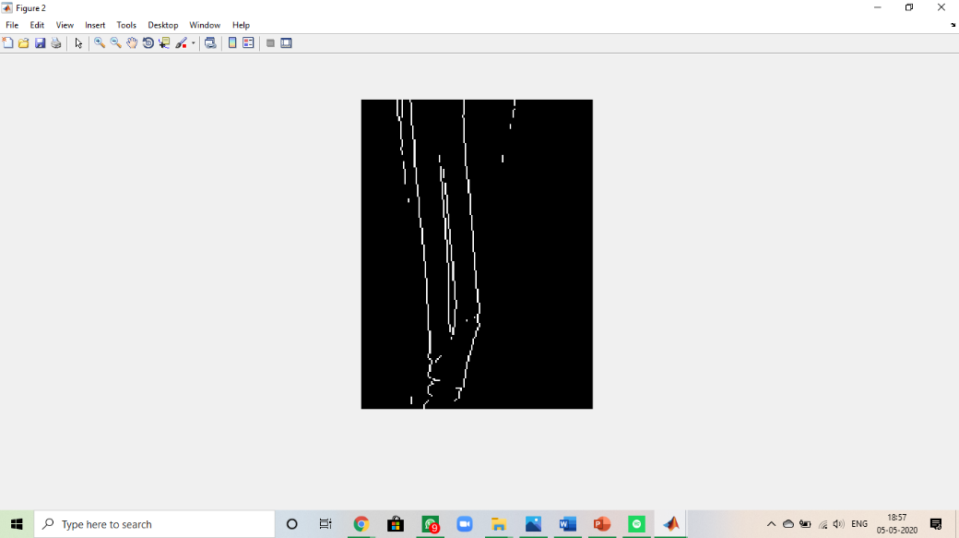

Canny:

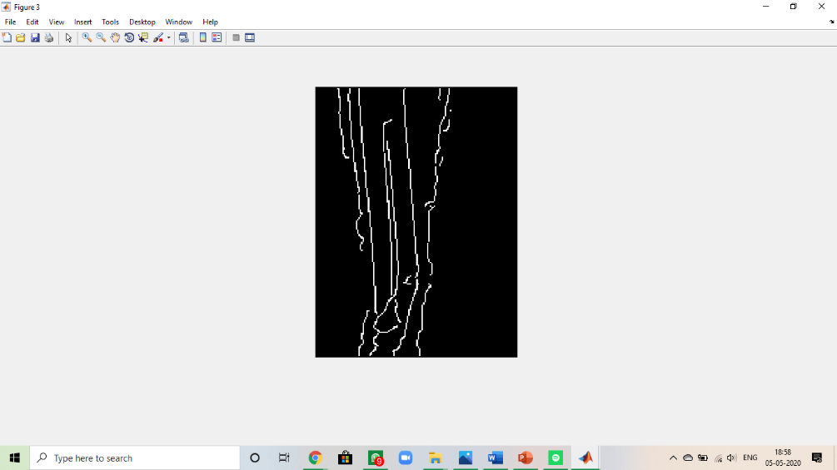

**Chapter 6**

**FUTURE SCOPE AND CONCLUSION**

**CONCLUSION**

This paper introduced the picture handling method to identify the bone fracture. The fully automatic detection of cracks in leg bone is a vital and however troublesome issue. As indicated by the test outcomes, the system has been done to recognize the bone split. An end can be made that the presentation of the revelation technique affected by the idea of the image. The better the image quality, the better the result structure got. In future work, focusing on various works like perceiving on smaller bone, lower leg splits etc may be considered.

From the above results we can conclude that the canny edge detection framework can be used in detecting fractured bones from x-ray images, which has been tested with real data. The simulation process of the results shows that the system needs to be improvised on performance and reduce the response time.

According to the test results which has been conducted to detect the bone fracture, we have obtained three images based on the process done. The better the image quality, the better the results from the system are obtained.

It is observed that canny method can produces good edge with the smooth continuous pixels and thin edge, whereas the sobel edge detection method cannot produce smooth and thin edge compared to canny method. Sobel and canny methods are very sensitive towards noise pixels, sometimes the nosiy images cannot be filtered perfectly due to this reason.

Hence, the fractured image is found and located using the canny method as this method provides better image quality out of all the above.

4

**The future scope of automatic future detection using image processing are characterized in following category :**

**1.**As the medical area is very sophisticated so to improve the accuracy, intense training set can be provided to improve the result.

2.The more complex algorithm can b implemented to show the shape , area and complexity of fracture.

3.Artificial intelligence can be used to improve the result and to analyze the characteristics of future and its cure.

4.Data mining techniques can be used to after detection of fracture to give more classification of fracture and cure which will be extracted from prior knowledge.

5.Through some improvement in above approach it can be used for fracture detection in other long bones.

6.The factor in logarithmic operator can be decided automatically through some statistical operators.

Feature Scope

Four different types of image features are extracted for fracture detection:

1. Femoral neck-shaft angle

2. Gabor filters

3. Markov Random Field (MRF)

4. Intensity gradient

The first feature is specifically extracted for detecting the distortion of shape due to severe femur fracture. The other features can potentially be applied for detecting fractures of various bones. So far, we have applied all of them to detecting femur fractures 99 and MRF to detecting radius fractures. Here, we shall give a summary of the method. Given the contour of the femur, it computes lines that are normal to both sides of the shaft contour, which we called the level lines. The line that passes through themed points of the shaft level lines gives a good approximation of the shaft axis. The level lines at the femoral head and neck are clustered into bundles. The mean direction of the level lines in the largest bundle that contains long level lines gives an initial approximation of the neck axis.

Then, taking note of the symmetry of the femoral head, the best axis of symmetry is determined, starting with the initial approximation, to obtain the best approximation of the shaft axis. Finally, the angle between the neck and the shaft axes is computed. Classification is based on a threshold of the neck-shaft angle that is learned from training samples, which is already explained in [3].

The extractions of the other three features share a common theme: adaptive sampling. The shapes and sizes of the bones are not identical in the x-ray images. Even among healthy bones, there are still differences in the appearance because they are naturally-occurring objects. Age and gender also contribute to the difference in the appearance of the bones. One standard method of dealing with size variation is to normalize the size of the bones in the images. This method is, however, unsatisfactory because it can either remove important texture information (if the image is shrunken) or introduce noise and artifacts (if the image is enlarged). Instead of scaling the x-ray images, adaptive sampling is used to sample the features so that the sampled locations in different images correspond to consistent locations in a normalized sampling grid

**REFERANCES**

* [www.nevonprojects.com](http://www.nevonprojects.com)
* [www.in.mathworks.com](http://www.in.mathworks.com)
* [www.ijitee.org](http://www.ijitee.org)
* [www.codeforge.com](http://www.codeforge.com)
* [www.ijarce.com](http://www.ijarce.com)
* [www.projectsinbangalore.com](http://www.projectsinbangalore.com)
* [www.ijecs.in](http://www.ijecs.in)
* [www.alldatasheets.com](http://www.alldatasheets.com/" \t "_blank)
* [www.digikey.com](http://www.digikey.com)
* [www.wikipedia.com](http://www.wikipedia.com)
* [www.electronicslab4u.com](http://www.electronicslab4u.com)

**Appendix:**

* Fracture detection
* Image processing
* Edge detection
* Segmentation
* X-ray image
* CT scan
* MRI
* FFT
* MATLAB